Year 10
OLNA class

Test 4

2018

Number- Fractions


Name: ______________________ Class: ______ Time: 25 minutes (strict) Total Mark:____/19

Resources: No calculator allowed

Question 1 1 mark

Convert $\frac{11}{4}$ to a mixed number

Question 2 1 mark

Convert 3 $\frac{5}{8}$ to an improper fraction

Question 3 1 mark

Billy made two types of cookies. He used ²/₃ cup of sugar for one recipe and ¹/₄ cup of sugar for the other. How much sugar (in cups) did he use in all?

Question 4 2 marks

Liam and Sam shared a chocolate bar. Liam ate ³/₅ and Sam ate ⁴/₁₀. Who ate more? How much more?

Question 5 1 mark

A running track is one kilometre long. If I jog for ¹/₆ km and run for ²/₃ km will I complete the full distance of the track?

Question 6 1 mark
A soldier drinks $\frac{2}{5}$ of a litre of water a day. How many litres will he need for 14 days?

Here are some previous topics…..
Question 7 4 marks
This is a train timetable from Norwich to Sheringham
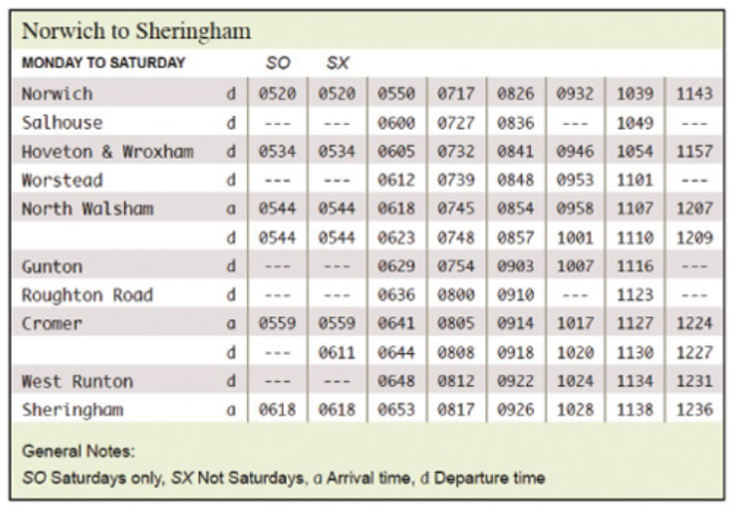
- What time does the 08.26 train from Norwich arrive at Cromer?

- Can I catch the 11.43 train from Norwich if I lived in Worstead?

- I want to be in Gunton by 7am. What train should I catch?

- How long is the journey from Norwich to North Walsham if I catch the 0717 train?

Question 8 1 mark
Solve the following:
- 35 – (17 – 2) ÷ 5

- (8² – 2⁵) ÷ (24 ÷ 6) + 3²

Question 9 4 marks
Solve the following:
- 6.453 x 100

- 30900 $÷10$

- 68 ×34

- 4375 $÷5$

END OF TEST

